Use the “subscription form” to subscribe a user
check email and confirm the susbscription

Check that the user status is “confirmed”
Press the button to edit the user profile

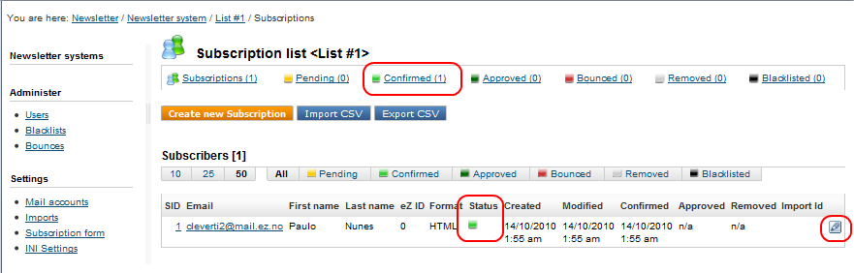

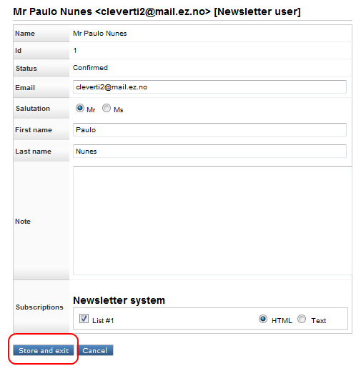
Then click “store and exit” - This is going to change the status to “Approved”, even if nothing warns about it.

After that, if we check the list of subscribers from the list we subscribed, the user is already with the status “approved”



